

FPGA High Speed Workshop Lab Manual - Cyclone V GX Edition
Tutorial

Copyright © 2018 Intel Corporation
All Rights Reserved
Revision: 002

Confidential

Legal Information
©2018 Intel Corporation. All rights reserved. ALTERA, ARRIA, CYCLONE, HARDCOPY, INTEL, MAX, MEGACORE, NIOS, QUARTUS and STRATIX words and logos are trademarks of Intel Corporation and registered in the U.S. Patent and Trademark Office and in other countries. All other words and logos identified as trademarks or service marks are the property of their respective holders as described at www.altera.com/common/legal.html. Intel warrants performance of its semiconductor products to current specifications in accordance with Intel's standard warranty, but reserves the right to make changes to any products and services at any time without notice. Intel assumes no responsibility or liability arising out of the application or use of any information, product, or service described herein except as expressly agreed to in writing by Intel. Intel customers are advised to obtain the latest version of device specifications before relying on any published information and before placing orders for products or service
Revision History
Revision Number | Description | Revision Date
<000> | Initial release. | February 2018
<001> | Minor changes done to the document:  - Added legal disclosure to document.  - Added a brief note on how each parameter change affects the IP behavior.  - Added a caution on Modelsim improperly behavior if the project path has whitespaces on it.  - Correction of forward slash / backslash on the simulation section of the manual.  - Add clarification related to the initial value for tx_sel_pattern switches.  - Added note on how to expand Modelsim panes to improve signal visibility. | June 2018
<002> | Added link to quartus project files, missing from previous rev. | October 2018

Contents
About this Document 4
Intended Audience 4
Using this tutorial 4
Conventions and Symbols 5
Related Information 5
Transceiver Design Flow§ 6
Building a transceiver channel 7
Block Diagram 7
Building the system 7
Step 1: Install tutorial files 7
Step 2: Open project and review design 8
Step 3: Create Cyclone V Transceiver Native PHY instance using IP Catalog 9
Step 4: Create Transceiver PHY Reset Controller using IP Catalog 14
Step 5: Review connections between IP cores and Pattern Generator 15
Step 6: Simulate to verify design functionality 17
Step 7: Review Pin Assigments 25
Step 8: Compile design and check all timing requirements have been met 27
Step 9: BringUp Development Board 28
Step 10: Perform System Test 30
Summary 37

§

About this Document
This is the laboratory manual for the High Speed IO workshop. The laboratory provides a practical introduction to the transceiver design flow for Intel FPGA. This document takes the student through the process of configuring and assembling a transceiver bidirectional channel, simulating its behavior and finally validating the design on a Terasic Cyclone V GX Starter Kit.

Intended Audience
This material is ideally suited for EE/CS students familiar with Boolean combinational logic and sequential logic. Familiarity with Intel FPGA design tools are not necessary but nice to have.

Using this tutorial
For this tutorial is required to download, install and load Quartus Prime Lite design software to your laptop. Allow 40+ minutes for the installation process. No license is required.
- Visit http://dl.altera.com/?edition=lite
- Select version 17.1 or higher and your PC's operating system. Make sure Edition "Lite" is selected.
- For the smallest/fastest download, unselect all, then only select "Quartus Prime (includes Nios II EDS)”, "Cyclone V device support" and Modelsim-Intel FPGA Edition.
- Click "Download Selected Files" and follow the prompts for installation.

Table 1 Document Organization
Section | Description
Transceiver Design Flow | A brief introduction to the design flow for applications that includes a transceiver for highspeed communication between members of a system.
Building a transceiver channel | A guide step by step to build simple transceiver design for Cyclone V GX devices.

Conventions and Symbols
The following conventions are used in this document.
Table 2 Conventions and Symbols used in this Document
This type style | Indicates an element of syntax, reserved word, keyword, filename, computer output, or part of a program example. The text appears in lowercase unless uppercase is significant.
This type style | Indicates the exact characters you type as input. Also used to highlight the elements of a graphical user interface such as buttons and menu names.
This type style | Indicates a placeholder for an identifier, an expression, a string, a symbol, or a value. Substitute one of these items for the placeholder.
[ items ] | Indicates that the items enclosed in brackets are optional.
{ item | item } | Indicates to select only one of the items listed between braces. A vertical bar ( | ) separates the items.
... (ellipses) | Indicates that you can repeat the preceding item.

Related Information
- Transceiver Architecture in Cyclone V Devices
- Cyclone V GX Starter Kit User Manual
- Intel® Quartus® Prime Standard Edition Handbook Volume 1 - Design and Synthesis
- SignalTap II Embedded Logic Analyzer Basics
- Intel FPGA Youtube Channel
- Transceiver PHY Landing Page

Transceiver Design Flow§
When developing a system that will include highspeed serial interfaces, it is a good practice to verify the configuration and correct operation of the transceiver channels isolate from other elements of the system. The figure below shows a workflow that helps us to achieve shorter times from design to system bring up for application with transceivers implemented on the FPGA.
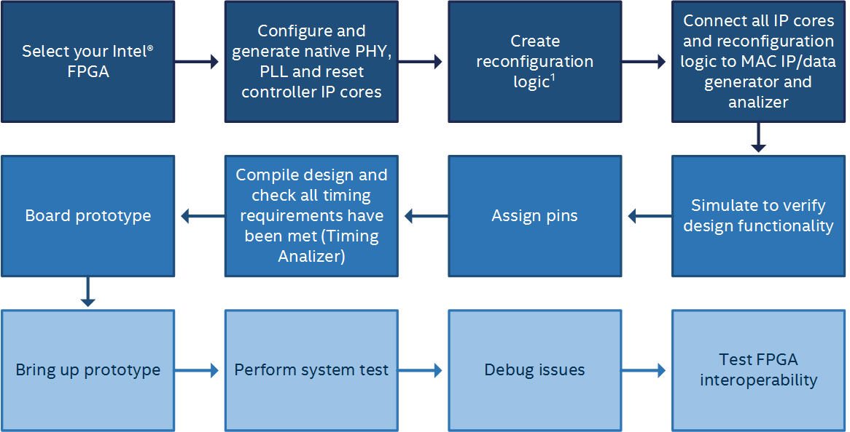
Each step on the tutorial maps to a task described in the previous flow. Even on a small design as the one described in this document, following all the steps will ease the transceiver channels bring up on the smaller amount of time.
- Step 1: Install tutorial files
- Step 2: Open project and review design
- Step 3: Create Cyclone V GX Transceiver Native PHY instance using IP Catalog
- Step 4: Create Transceiver PHY Reset Controller using IP Catalog
- Step 5: Review connections between IP cores and Pattern Generator
- Step 6: Simulate to verify design functionality
- Step 7: Review Pin Assignments
- Step 8: Compile design and check all timing requirements have been met
- Step 9: Bring up Development Board
- Step 10: Perform System Test

Building a transceiver channel

Block Diagram
This is a simple base design that implements a loopback connection between a single TX and RX channel from a Cyclone V GX transceiver native physical layer (PHY). A reset controller is instantiated to handle the reset flow for the transceiver. Finally, a data generator block provides an alignment pattern to train the link between TX and RX channels and then shift to a data payload generation to transmit between channels.
A native PHY module expose all internal hardware blocks from a transceiver channel, offering the designer a greater level of flexibility to implement custom communication protocols. Also, a list of presets is offered to the designer to implement popular communication protocols with a native PHY.

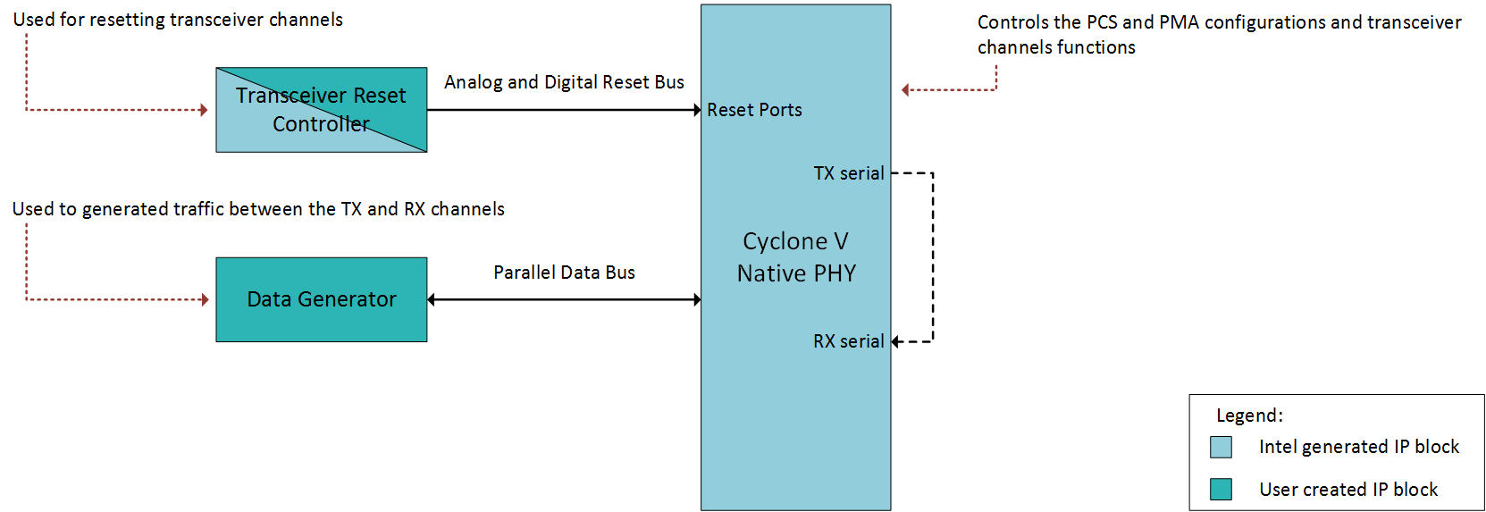

Building the system
The next steps take you through the process of configuring and connecting the required modules to assemble a pair of TX/RX transceiver channels on a loopback connection. The steps take you from the assembly to the hardware validation of the design.

Step 1: Install tutorial files
You can download the lab files from this link: http://www.alterawiki.com/wiki/File:5cgx_xcvr_tutorial.zip. Copy ‘5cgx_xcvr_tutorial.zip’ to your computer. This tutorial expects that the destination folder of the project files is the root directory of your computer (C:\). If you are using a different location, make sure that you adjust all reference to the project directory according.
Make sure that the destination path for 5cgx_xcvr_tutorial.zip does not include any whitespaces. If your path includes whitespaces, you will run into issues through the simulation section of this manual as the simulation tool will not work properly.
Extract the files in the target folder. A new folder called ‘5cgx_xcvr_tutorial’ will be created, and it should contain the ‘5cgx_xvcr_1G’ folder with the following files:
- 5cgx_xcvr_1G.qpf
- 5cgx_xcvr_1G.sdc
- 5cgx_xcvr_1G_pins.tcl
- mentor_top_reference.do
- parallel_data_snoop.stp
- top.qsf
- top.v
- top_tb.v
- wave.do

Step 2: Open project and review design
Open Quartus 17.1 lite, then click ‘File’ and select ‘Open Project…’
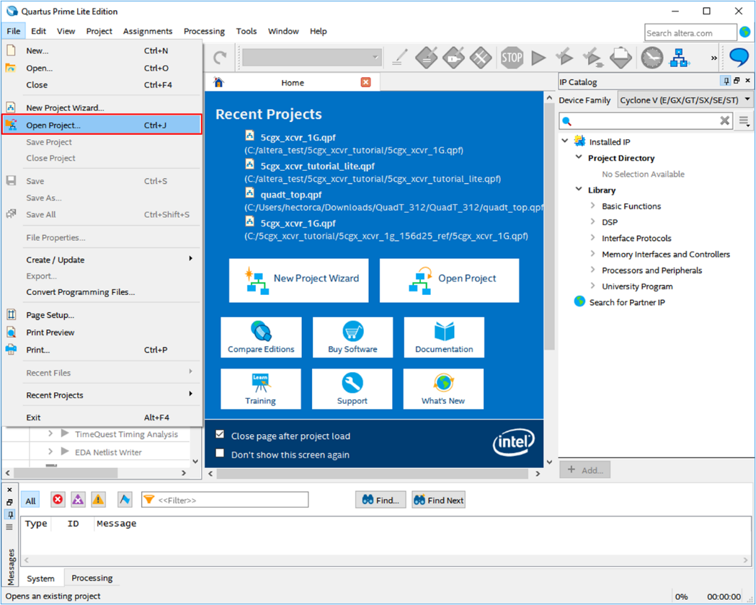
Navigate to the folder where the tutorial was uncompressed and select ‘5cgx_xcvr_1G.qpf’, then click ‘Open’.
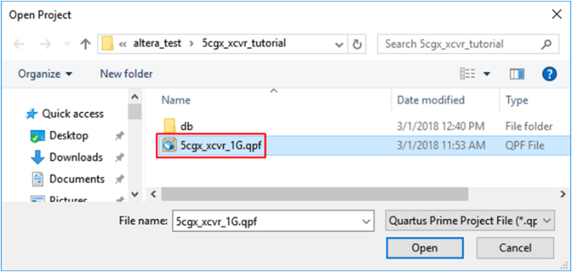

Step 3: Create Cyclone V Transceiver Native PHY instance using IP Catalog
Go to IP Catalog and search for ‘native phy’, double click on ‘Cyclone V Transceiver Native PHY v17.1’
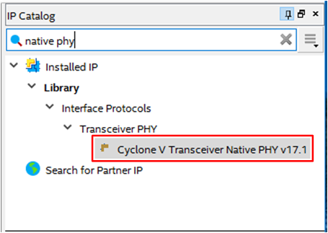
Name ‘native_phy_1G’ the new IP variation. Make sure that ‘Verilog’ is selected as the file type. Click ‘OK’ once you have finished.
Using a different naming convention for the IP will result in errors on the next steps of the tutorial.
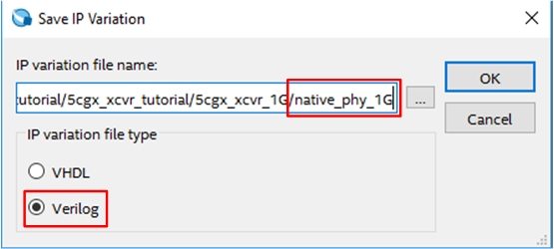
IP configuration wizard will launch. Before starting the IP configuration, make sure that the correct native PHY is being instantiated ‘Cyclone V Transceiver Native PHY’.
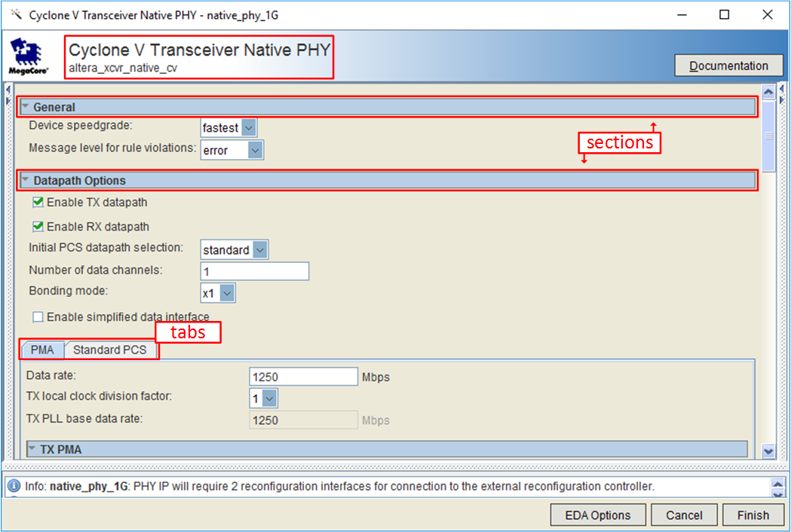
The configuration wizard is organized into sections and tabs, this structure will be used to configure the IP variation. ‘General’ and ‘Datapath Options’ sections will be configured first, change the IP default parameter values only when it is indicated.
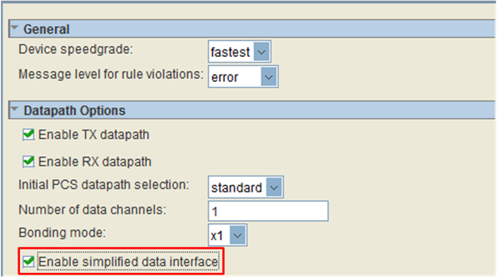
In ‘Datapath Options’ check ‘Enable simplified data interface’, all other parameters should remain the same. By selecting ‘Enable simplified data interface’ all unused signals from the native PHY will be grouped together, making easier the module instantiation. Take a moment to make sure that the configuration is the same as the one shown in the previous figure.
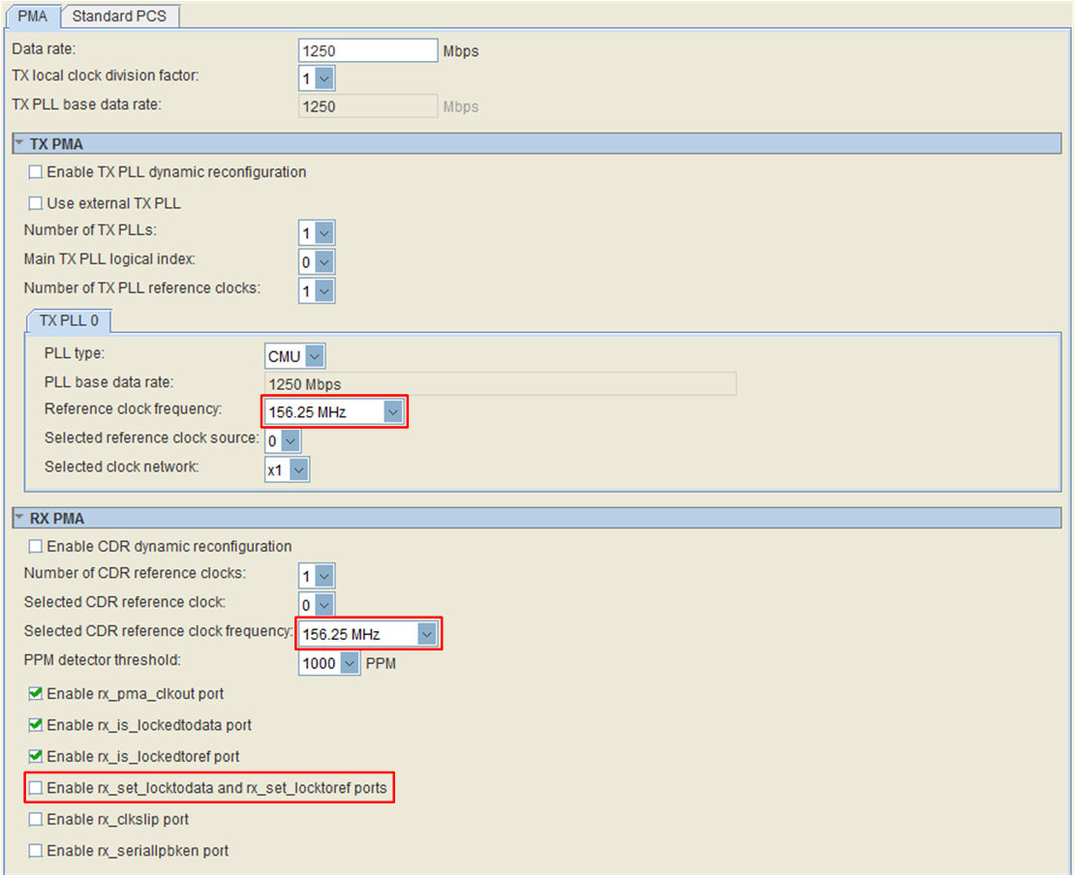
Move to ‘PMA’ configuration tab, all parameters will remain in their default values in its general section. On ‘TX PMA’ section, set the ‘Reference clock frequency’ to ‘156.25 MHz’. On ‘RX PMA’ section, set ‘Selected CDR reference clock frequency’ to ‘156.25 MHz’. Reference clock selection depend on the PLL type and the desired data rate, the TX/RX PLLs need to be able to generate a clock signal high enough to achieve the desired data rate based on the provided reference. Quartus will display all reference clock frequencies that the TX/RX PLLs can use to achieve the target data rate. Continue with the IP configuration unchecking ‘Enable rx_set_locktodata and rx_set_locktoref ports’, those port are used to manually drive the CDR recovery clock process and will not be used for this design. All remaining parameters should remain to their default values.
Click on ‘Standard PCS’ tab. General options, ‘Phase Compensation FIFO’ section, ‘Byte Ordering’ section, ‘Byte Serializer and Deserializer’ section, ‘Rate Match FIFO’ section and ‘Bit Reversal and Polarity Inversion’ section, will keep their default parameters values. Be aware that ‘FPGA fabric / Standard TX PCS interface width’ and ‘FPGA fabric / Standard RX PCS interface width’ values are affected by other parameters on the ‘Standard PCS’ tab. For this tutorial, both values will set to ‘10’ until the ‘8B/10B Encoder and Decoder’ blocks are activated. After the later blocks are enabled, the ‘FPGA fabric / Standard RX PCS interface width’ value will change to ‘8’.
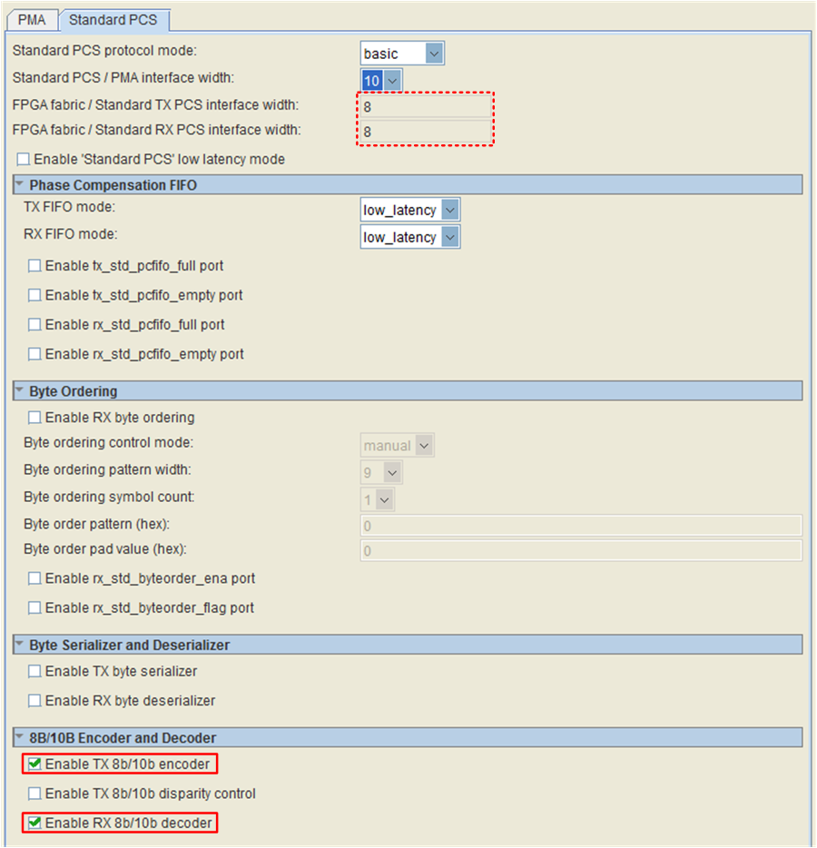
On section ‘8B/10B Encoder and Decoder’, check both ‘Enable TX 8b/10b encoder’ and ‘Enable RX 8b/10b decoder’. This change will trigger an update on ‘FPGA fabric / Standard TX PCS interface width’ and ‘FPGA fabric / Standard RX PCS interface width’ values, they will change from ‘10’ to ‘8’.
On Section ‘Word Aligner and Bitslip’, change ‘RX word aligner mode’ to ‘sync_sm’. ‘RX word aligner pattern length’ should be set to ‘10’. ‘RX word aligner pattern (hex)’ must be set to ‘17C’ pattern. This change adds a FSM that will help to align the TX/RX communication channels, the alignment consists on transmitting a previously known pattern from TX to RX. The RX channel is aware of the alignment pattern and will wait until it receives the defined number of word pattern to declare that both TX and RX channels are in sync. Continuing with the IP configuration, all other parameters must remain the same.

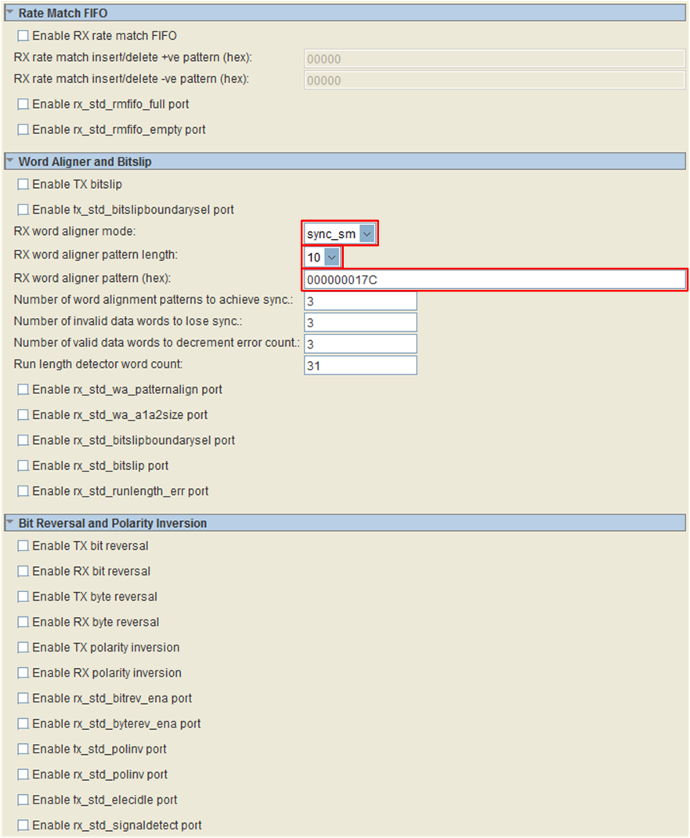
Once the changes had taken place, click ‘finish’ button, the wizard will start the IP variation generation. Once the generation process is over a ‘Generation Successful’ message will show up. Click ‘Exit’. When prompted, click ‘yes’ to add the IP variation to the project.
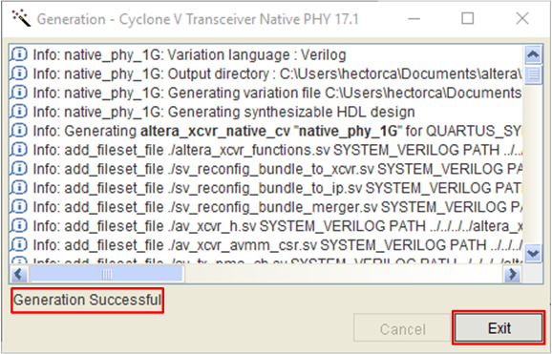
Congratulations! Cyclone V Transceiver Native PHY is complete.

Step 4: Create Transceiver PHY Reset Controller using IP Catalog
Go to IP Catalog and search for ‘reset controller’, double click on ‘Transceiver PHY Reset Controller’.
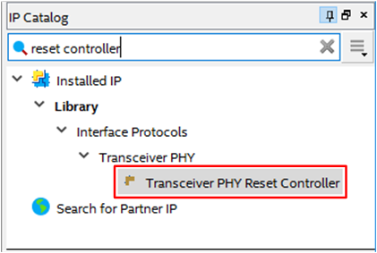
Name ‘reset_controller_1G’ the new IP variation. Make sure that ‘Verilog’ is selected as file type. Click ‘OK’ once you have finish.
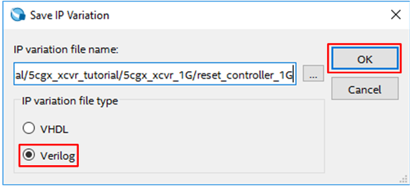
IP configuration wizard will launch. Before starting the IP configuration, make sure that the correct IP is being instantiated ‘Transceiver PHY Reset Controller’. ‘Arria 10 Default Settings’ preset will be used for this IP, double-click on the preset name and all IP parameters will be changed accordingly. The Arria 10 default preset sets a delay to drive each control signal involved on the bring up of the PLLs and the native PHY, these values fulfill the Cyclone V spec, so we will be using them.
After preset values have been taken, proceed to change the ‘Input clock frequency’ parameter to ‘50’ as a clock running at 50 MHz will be feed to the reset controller.
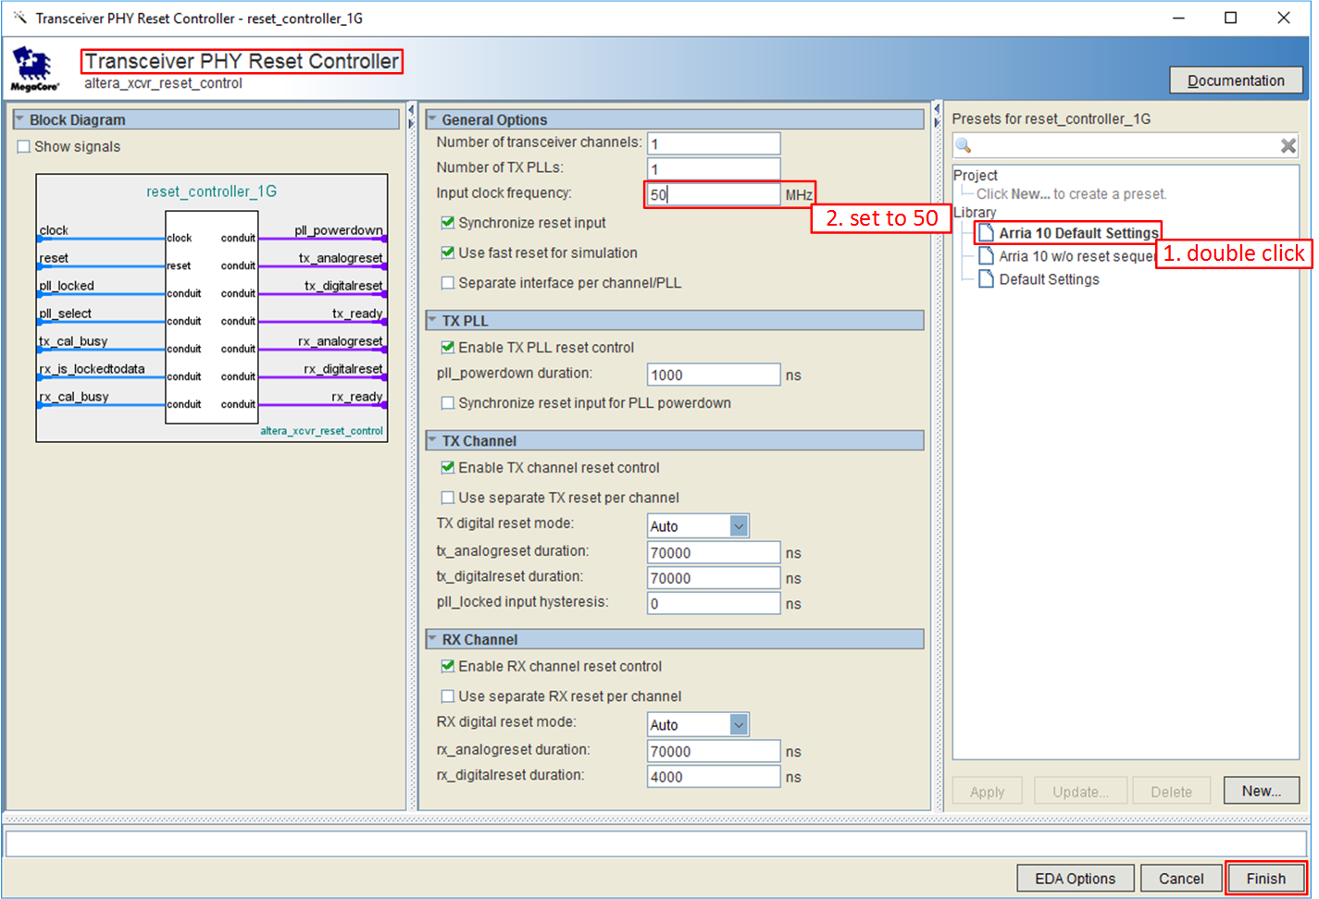
Once the changes had taken place, click ‘Finish’ button, the wizard will start the IP variation generation. Once the generation process is over a ‘Generation Successful’ message will show up. Click ‘Exit’. If you are asked if you would like to add the IP variation to the project, click ‘yes’.
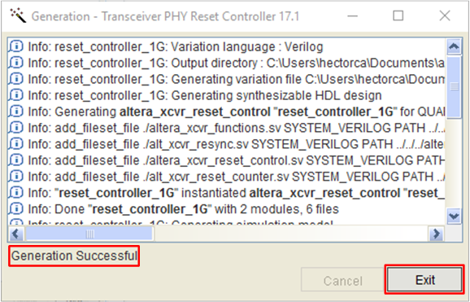
Congratulations! Transceiver PHY Reset Controller is complete.

Step 5: Review connections between IP cores and Pattern Generator
Double click on ‘top’ in ‘Project Navigator’. ‘top.v’ will open on a text editor. Look at modules being instantiated:
native_phy_1G: Cyclone V Transceiver Native PHY
reset_controller_1G: Transceiver PHY Reset Controller
Those instances are from the IPs just created on the previous steps. At the end of the file look for ‘//LOGIC: Pattern Generator’, all logic described in this section generates the data patterns feed to the transceiver TX channel.
No editing is required in this file. The connections between the IPs have been made.
top.v follows the connections described on the figure shown in ‘Block Diagram’ section at the beginning of this chapter.
top.v was created considering that the user has named all IP with the names proposed in this document. Changing the name of an IP will require this modify this file according. Editing this file require notions of Verilog HDL.

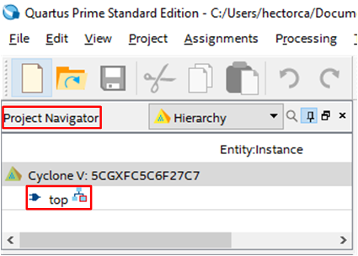
On the ‘Tool bar’ click ‘Start Analysis and Elaboration’ icon to start the process and verify the correctness of the connectivity between IPs.
If everything is correct, a no error will appear on the message console.
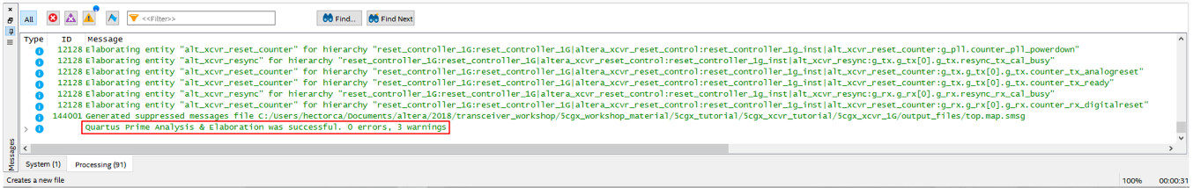
Click on the warning icon on the message console to filter all messages except for warnings. Only three warning messages should remain, and they can be safely ignored.
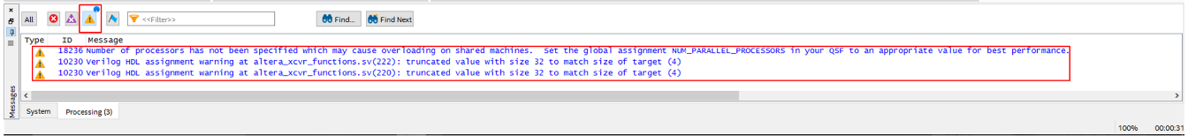
Congratulations! The IPs are now fully connected. You have proven that the design syntax is correct, and the libraries have linked. You have not run the place and route steps (fitting). That step will be done later.

Step 6: Simulate to verify design functionality
For this step, you will require to record two paths from your system. First, look for your Quartus installation path:
E.g. C:\intelFPGA\17.1\quartus
Also, you will need your project path:
E.g. C:\5cgx_xcvr_tutorial\5cgx_xcvr_1G
If your project path includes whitespaces the simulation tool will not work properly. Please reallocate your project files to a path without whitespaces.
First, we Will generate a unified simulation compile script for both of our IPs, follow the next steps:
- Open a File Explorer window and navigate to your project folder.
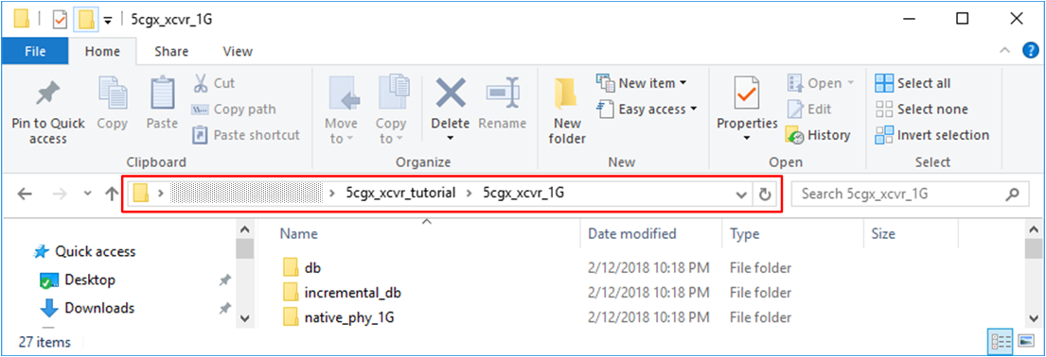
- Once in your project folder, click on the address bar and write ‘PowerShell’, press ‘Enter’. A PowerShell console will show up.
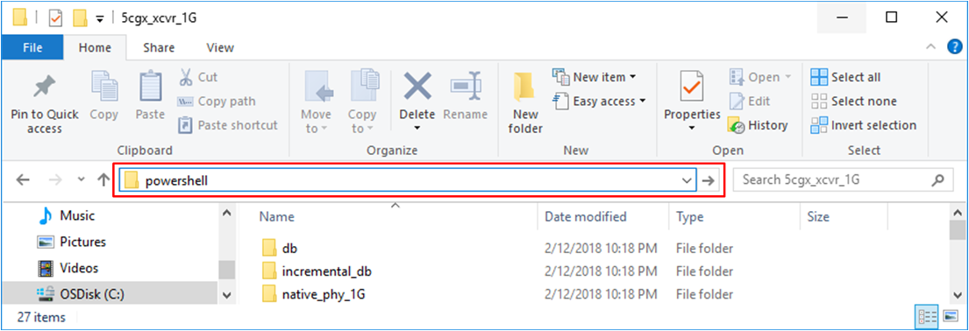
- Write the following command in the Power Shell window. Substitute <quartus_path> for your own Quartus installation path:
The backtick (`) symbol indicates to windows Power Shell that the current line is not the end of a command, that it will continue the next line. As an alternative, the next command can be typed on a single line omitting the backticks. <quartus_path> must use forward slashes.
<quartus_path>\sopc_builder\bin\ip-make-simscript.exe `
--spd=native_phy_1G.spd `
--spd=reset_controller_1G.spd `
--use-relative-paths
Press ‘Enter’.
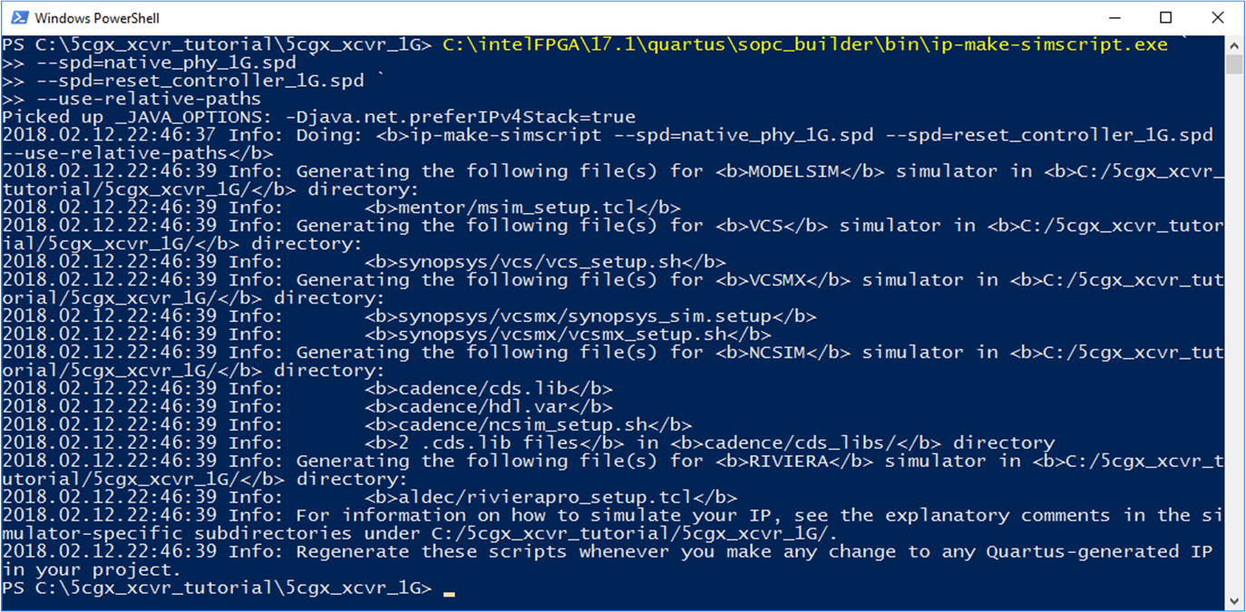
Now, you should have a folder named ‘mentor’ among other new files in your project folder.
You need to perform steps 1 to 3 if you make any changes to the IPs in the project. If a change is made to an IP, and the compile scripts are not refreshed, the simulation will not reflect the proper behavior of the system.
The .spd file contains a list of files generated for simulation, along with information about memories that you can initialize. SPD files are required inputs for the ip-make-simscript command, that will use the files contents to generate simulation scripts for supported simulators.

- Go back to your project folder. Create a new file named mentor_top.do. Leave it blank for now.
- In your project folder, open ’<project_path>\mentor\msim_setup.tcl’ with you preferred text editor.
- From msim_setup.tcl, select and copy from line 32 to line 83. The first three lines of your selection should be:
# ----------------------------------------
# # TOP-LEVEL TEMPLATE - BEGIN
# #
The last three lines should be:
# #
# # TOP-LEVEL TEMPLATE - END
# ----------------------------------------
- Paste the msim_setup.tcl content into mentor_top.do. The first three lines from mentor_top.do should be:
# ----------------------------------------
# # TOP-LEVEL TEMPLATE - BEGIN
# #
- Do the following changes on mentor_top.do:
Modelsim use forward slash instead of backslash as directory dividers. Make sure that all paths that are used by modelsim are typed with forward slashes.
Line 12: Remove the sharp character at the beginning of the line and substitute <script generation output directory> with the path to your project. Use backslash as divider between folders. It should look like:
set QSYS_SIMDIR C:/5cgx_xcvr_tutorial/5cgx_xcvr_1G
Line 15: Remove the sharp character at the beginning of the line.
source $QSYS_SIMDIR/mentor/msim_setup.tcl
Line 23: Remove the sharp character at the beginning of the line.
dev_com
Line 26: Remove the sharp character at the beginning of the line.
com
Line 32: Remove the sharp character at the beginning of the line. Substitute <compilation options> with -work work -vlog01compat. Substitute <design and testbench files> with top.v top_tb.v. Your line should look like:
vlog -work work -vlog01compat top.v top_tb.v
Line 37: Remove the sharp character at the beginning of the line. Substitute <simulation top> with top_tb.
set TOP_LEVEL_NAME top_tb
Line 40: Remove the sharp character at the beginning of the line. Substitute <elaboration options> with -voptargs="+acc".
set USER_DEFINED_ELAB_OPTIONS -voptargs="+acc"
Line 43: Remove the sharp character at the beginning of the line.
elab
Line 45: Press ‘Enter’ to create a new line. Type do wave.do on new line 46, press ‘Enter’. On new line 47 type run 200 us.
do wave.do
run 200 us
- Safe the changes to mentor_top.do.
After the changes your mentor_top.do file must look like:
# ----------------------------------------
# # TOP-LEVEL TEMPLATE - BEGIN
# #
# # QSYS_SIMDIR is used in the Quartus-generated IP simulation script to
# # construct paths to the files required to simulate the IP in your Quartus
# # project. By default, the IP script assumes that you are launching the
# # simulator from the IP script location. If launching from another
# # location, set QSYS_SIMDIR to the output directory you specified when you
# # generated the IP script, relative to the directory from which you launch
# # the simulator.
# #
set QSYS_SIMDIR C:/5cgx_xcvr_tutorial/5cgx_xcvr_1G
# #
# # Source the generated IP simulation script.
source $QSYS_SIMDIR/mentor/msim_setup.tcl
# #
# # Set any compilation options you require (this is unusual).
# set USER_DEFINED_COMPILE_OPTIONS <compilation options>
# set USER_DEFINED_VHDL_COMPILE_OPTIONS <compilation options for VHDL>
# set USER_DEFINED_VERILOG_COMPILE_OPTIONS <compilation options for Verilog>
# #
# # Call command to compile the Quartus EDA simulation library.
dev_com
# #
# # Call command to compile the Quartus-generated IP simulation files.
com
# #
# # Add commands to compile all design files and testbench files, including
# # the top level. (These are all the files required for simulation other
# # than the files compiled by the Quartus-generated IP simulation script)
# #
vlog -work work -vlog01compat top.v top_tb.v
# #
# # Set the top-level simulation or testbench module/entity name, which is
# # used by the elab command to elaborate the top level.
# #
set TOP_LEVEL_NAME top_tb
# #
# # Set any elaboration options you require.
set USER_DEFINED_ELAB_OPTIONS -voptargs="+acc"
# #
# # Call command to elaborate your design and testbench.
elab
# #
# # Run the simulation.
# run -a
do wave.do
run 200 us
# #
# # Report success to the shell.
# exit -code 0
# #
# # TOP-LEVEL TEMPLATE - END
# ----------------------------------------
- Open ModelSim – Intel FPGA Starter Edition. On ‘Transcript’ window enter the following command cd <project folder>.
Moldelsim utilize the forward slash character as divider between folders. Windows use the backslash as divider between folder. You will need to use the forward slash notation while changing directories in modelsim as show in the next figure or wrap the path in curly brackets in case that you want to use backslash notation (e.g. cd {C:\5cgx_xcvr_tutorial\5cgx_xcvr_1G}).
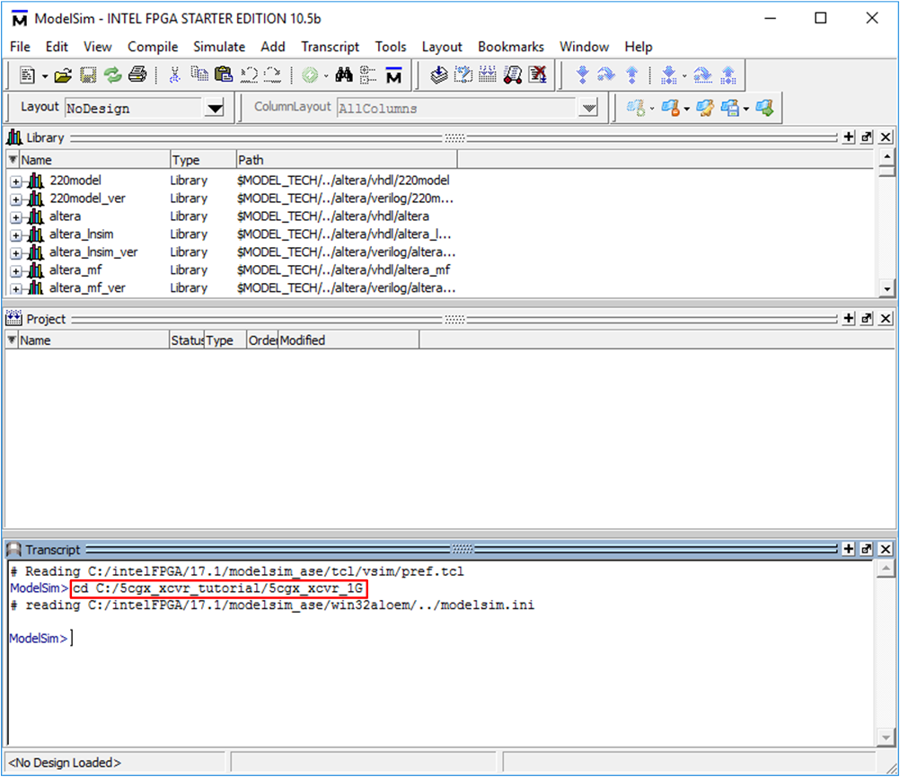
- On ‘Transcript’ window enter the following command do mentor_top.do. The simulation will start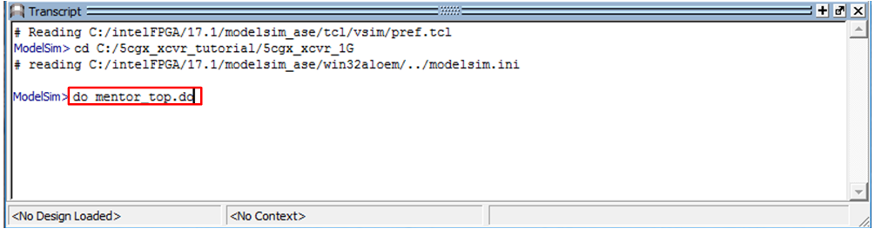
- If everything is correct, your ModelSim window should look like:
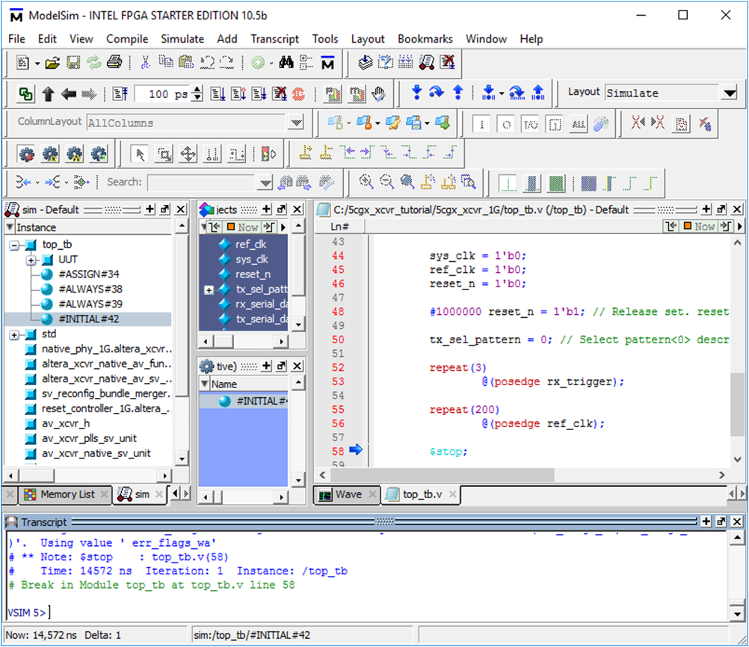
Waveform Analysis
Change Modelsim layout for waveform analysis. First click on the ‘Wave’ tab to bring up the waveform.
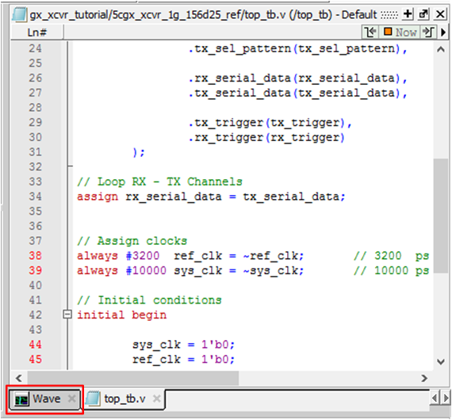
Click the ‘expand’ button to display the waveform across Modelsim window.
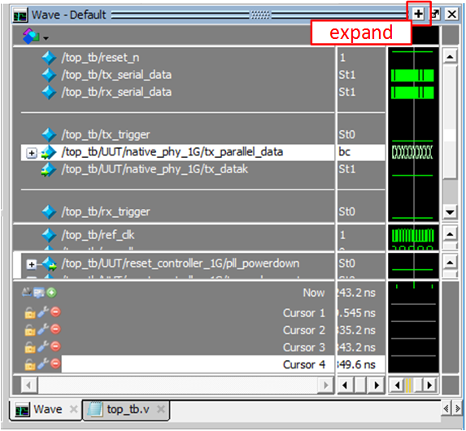
Use the zoom controls to adjust the waveform. Click on ‘Zoom Full’ button to start.
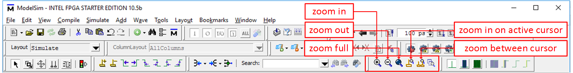
The waveform is organized in three windows panes, Data pane, Clock pane and Reset pane. This waveform is delivered as part of the material from this tutorial and includes the most relevant signals that intervene on the transceiver channels operation. However, the user is free to add additional signals to further explore the design behavior. Data pane groups all signals related to data transfer between TX and RX channels. Clock pane shows clock signals used to calibrate the channels PLLs and the clock signal used to drive the FPGA logic that feeds data into the TX channel. Finally, reset pane have signals used to reset the TX/RX channels. There are also three areas of special interest on the waveform: ‘Reset Sequence’, ‘Channel alignment’ and ‘Data reception’.
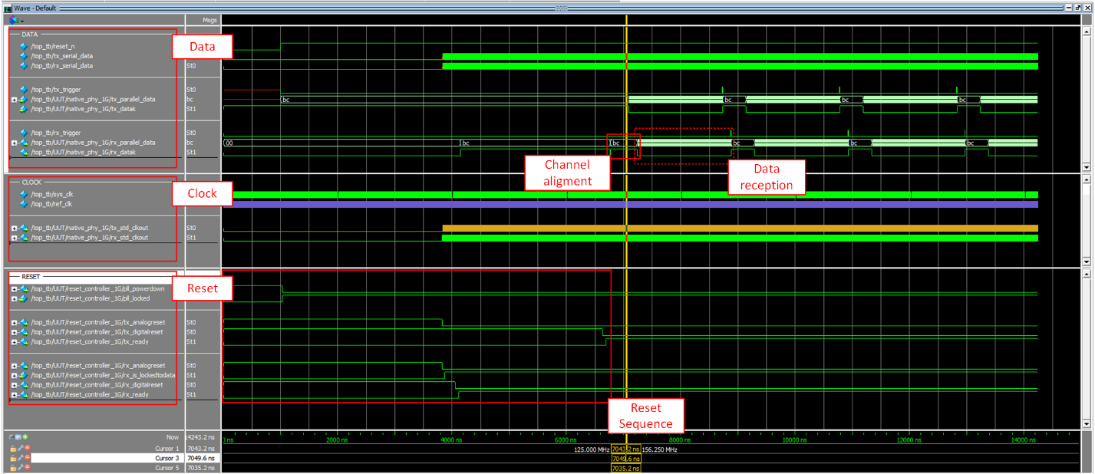
If not all the signals are visible on any of the panes, click the line dividing the panes and drag it to increase or decrease the size of the pane.
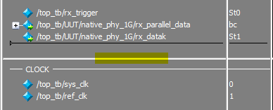

The reset flow for the TX/RX channels is managed by the reset controller. The controller holds on reset both TX and RX PLLs. After the wait time set on the reset controller, the module starts the bring up of both channels (tag 1 on the figure below). For the RX channel, the reset controller first lets out of reset the PMA of the channel, the latter start recovering the clock signal from the incoming data, once this process is done, the PMA sets ‘rx_is_lockedtodata’ signal to let know the reset controller that the analog portion of the channel is ready. After that, the reset controller takes out of reset the PCS from the RX channel, after a waiting time for the RX PCS to get ready, the controller sets the ‘rx_ready’ signal to let know that the RX channel is ready to operate (tag 2 on the figure below). The TX channel sets out of reset the PMA portion of the channel, it waits until the PMA PLL has been calibrated and then it takes out of reset the PCS. Once the flow has ended for the TX channel, the reset controller asserts the ‘tx_ready’ signal to let know that the TX channel is fully operational (tag 3 on the figure below).
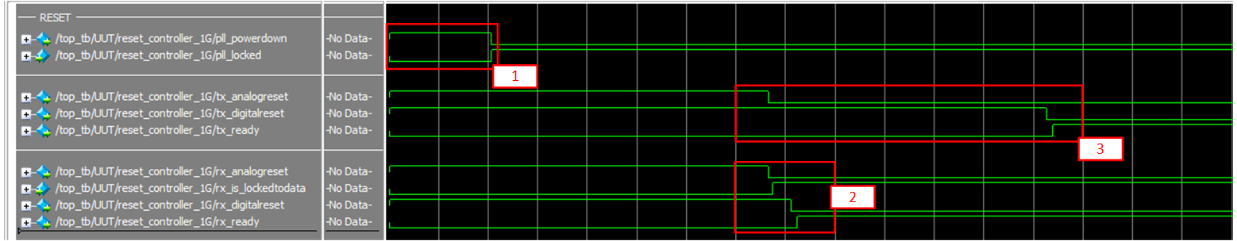
Data transaction between TX and RX channel take place in two phases. In the first phase, TX channel starts sending the alignment pattern ‘BC’, this pattern is sent 50 times to align both channels. While TX is sending the alignment pattern, signal ‘tx_datak’ must be set to one to indicate to the ‘8b/10b encoder’ block that the symbol being sent must be encoded as a control symbol. Once the channels are aligned, ‘tx_datak’ is set to zero and the TX channel starts the transmission of data symbols. After the first data symbols have been processed by all the internal blocks from the RX PMA and RX PCS the decoded symbol is available at ‘rx_parallel_data’ port. The number of delay cycles between a data symbol arriving to ‘tx_parallel_data’ port and its exit through ‘rx_parallel_data’ port is affected directly by the number of blocks that the symbol must cross through the TX PCS, TX PMA, RX PMA and RX PCS.
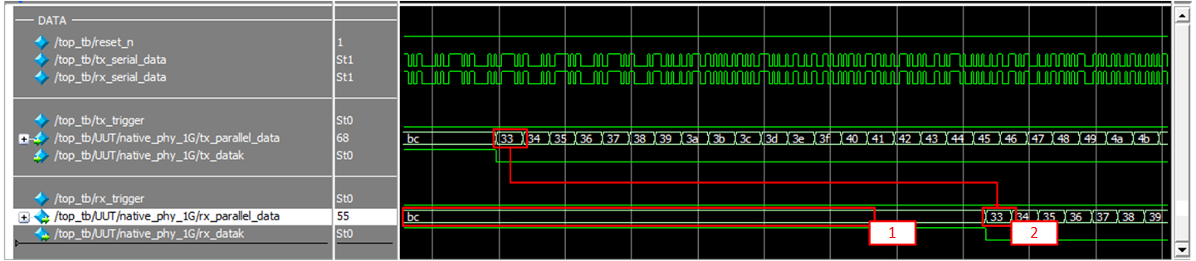
‘ref_clk’ and ‘tx_std_clkout’ are clock signals directly involved in the transceiver operation. ‘ref_clk’ is used to calibrate the PLL used for the TX and RX channels. ‘ref_clk’, as it is used as reference for calibration, do not necessarily run at the same frequency that the clock signal used to capture/transmit data on the physical medium, also, it does not have to run at the same speed as the signal that is used to clock the FPGA core logic that generates/process the data to and from the transceiver channels. In this exercise we are using a 156.25 MHz clock as reference for PLL calibration.
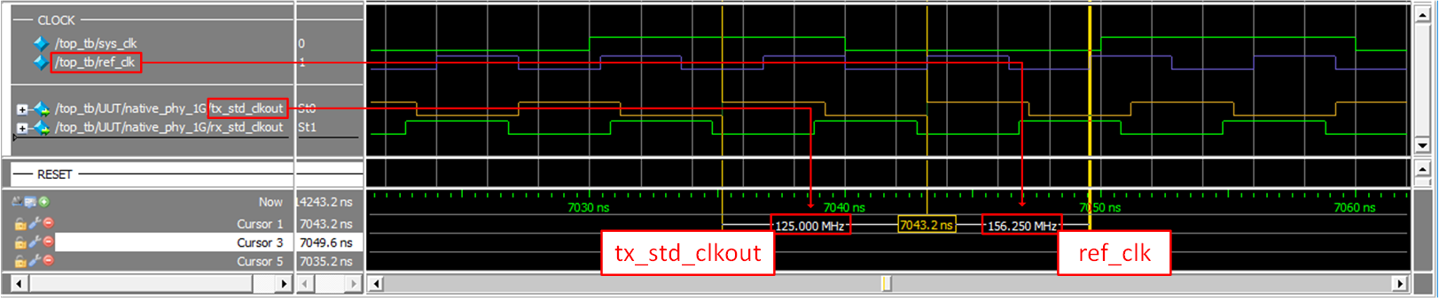
‘tx_std_clkout’ is the clock signal used to drive all blocks that are part of the PCS of a transceiver channel. In this example, ‘tx_std_clkout’ is running at 125 MHz, which is not the same frequency used for the PLL calibration. ‘tx_std_clkout’ has a direct relationship between the desired bandwidth and the size of the interface between the PMA and PCS for the transceiver channels. In this example, our desired bandwidth is 1250 Mbps and our PMA/PCS interface is 10 bits wide, so we need to do 125M transactions between PMA and PCS each second. To achieve this, we need to drive our PCS logic at 125 MHz.
Congratulations! the design is behavioral validated.

Step 7: Review Pin Assigments
On Quartus, click on ‘Tools’ and then click ‘Tcl scripts…’.
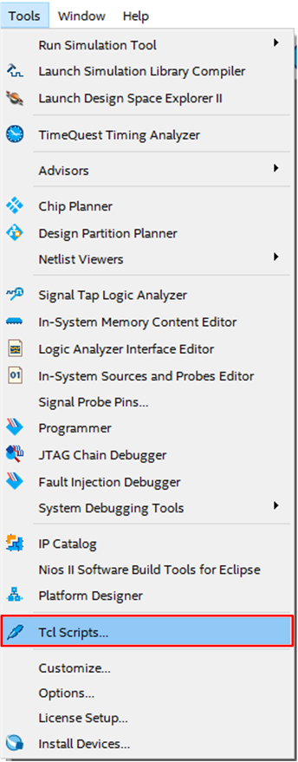
A new window will show up, select 5cgx_ xcvr_1G_pins.tcl and then click ‘Run’. Quartus will load the pin assignment to the project. ‘5cgx_xcvr_1G_pins.tcl’ comes as part of the material for this tutorial and is intended to be used exclusively with the Terasic Cyclone V GX Starter Kit.
Using the pin assignments contained in ‘5cgx_xcvr_1G_pins.tcl’ with a development board different from the Terasic Cyclone V GX Starter Kit, may cause permanent damage to it. Avoid using a different development kit, or if you are an experienced user modify the pin assignments according.
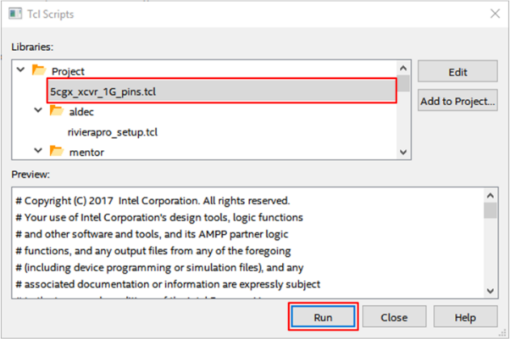
Click on ‘Assignments’ menu and click on ‘Pin Planner’.
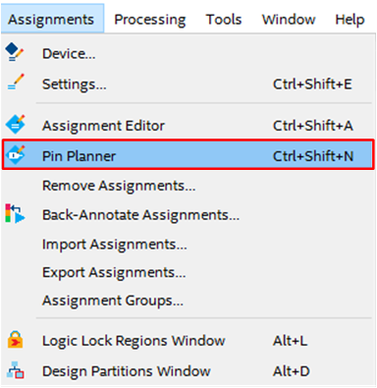
If everything its correct, ‘Pin Planner’ should look like:
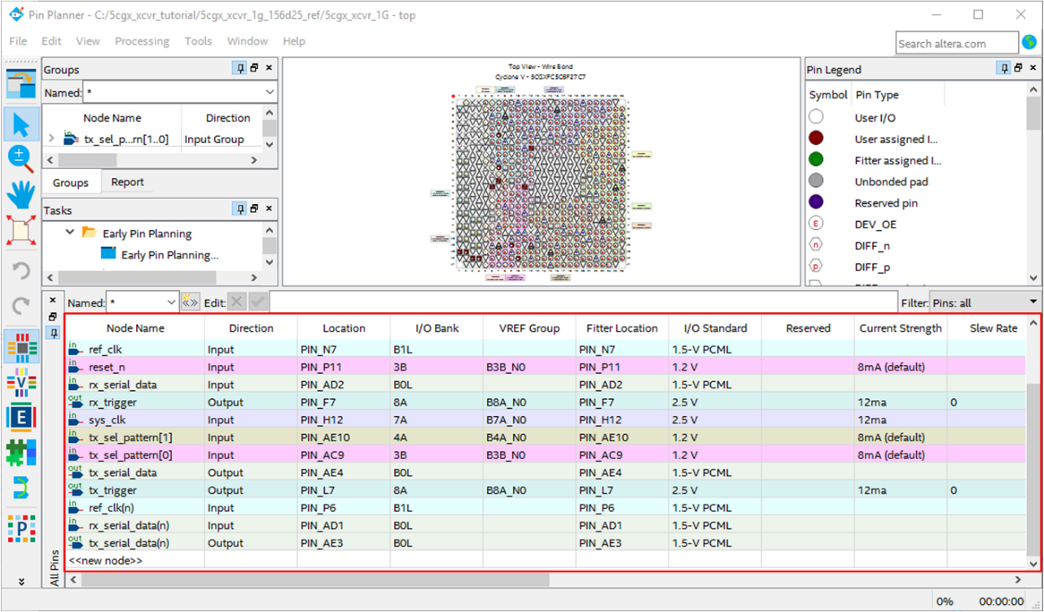
Congratulations! The pin assignments are done.

Step 8: Compile design and check all timing requirements have been met
Timing constraints has been included within the project, you can review them opening the next file in your preferred text editor <project_folder>/5cgx_xcvr_1g.sdc. This file was created for you and is already included in the project, so no further action is required.
This step will validate that the design is ready to be download into an FPGA. As a result of this step, a ‘.sof’ file will be generated.
To start the compile process, click on the ‘Start Compilation’ button on the tool bar.
After the process is completed, in Quartus ‘Message Console’ you should see a message saying that the compilation was successful and that no errors were encounter. The entire process should take around 2 minutes.
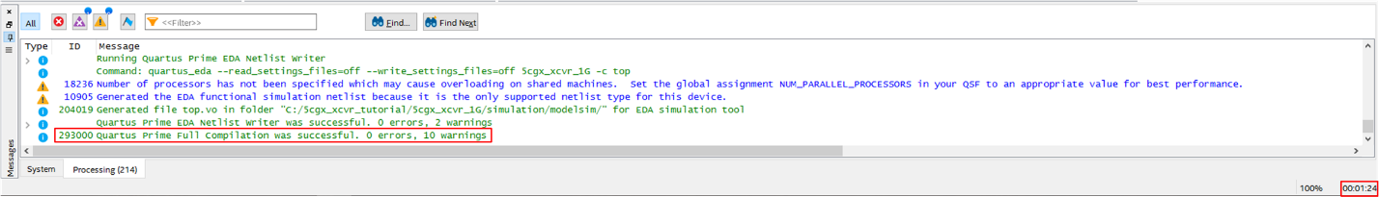
Finally, on the ‘Compilation Report’ make sure that one RX channel and one TX channel are being utilized for the current design.
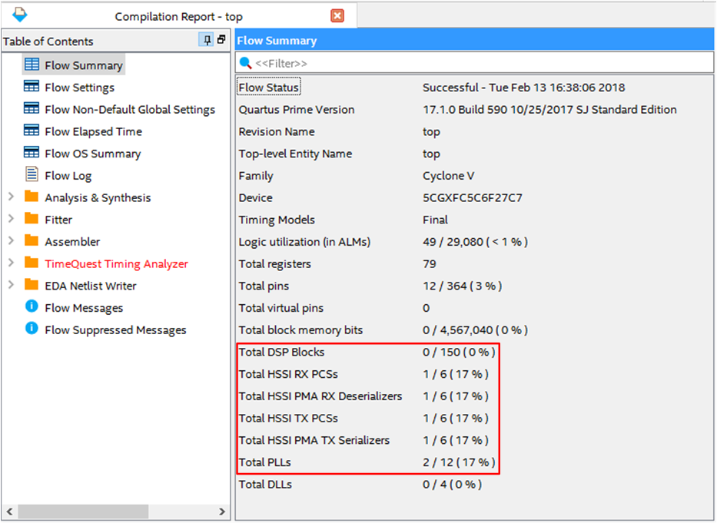
Congratulations! The design had successfully compiled.

Step 9: BringUp Development Board
Before running this design into the Terasic C5G Starter Kit, review the following settings:
- Switch 11 (SW11) is set to ‘RUN’
- Jumper 13 (JP13) is in ‘OFF’ position
Follow the next steps to turn on the board:
- Connect the Loopback between transceiver channels on the High-Speed Mezzanine Card (HSCM) connector. This card will connect the TX channel from the design directly with the RX channel. This will let us capture all traffic going out of the FPGA into the RX channel.
- Connect the power supply to the board.
- Connect the USB cable into the USB Blaster connector. Make sure that you are using the USB port closer to the power jack. Use the next figure as reference.
- Turn on the board pressing the red button next to the power supply barrel connector.
To ensure the proper operation of the transceiver TX and RX channels the loopback connection between them must be in place before you power up the board.
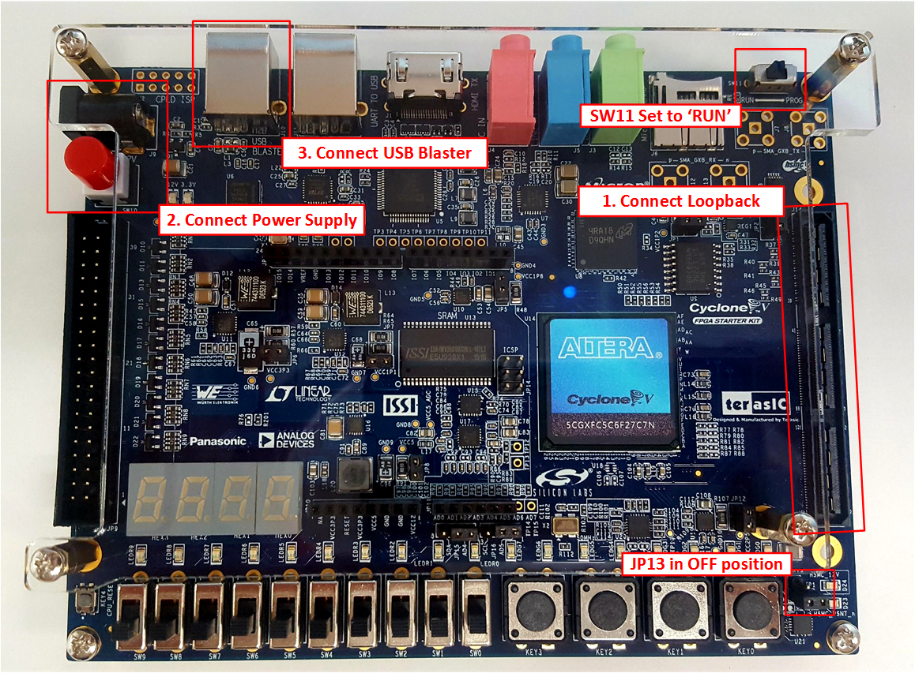

The next table shows the mapping between visible top-level signals to peripherals in the development kit:
Signal | Peripheral
reset_n | KEY0
tx_sel_pattern[1:0] | SW1 and SW0
tx_trigger | LEDG0
rx_trigger | LEDR0
TX/RX Loopback | HSMC Connector

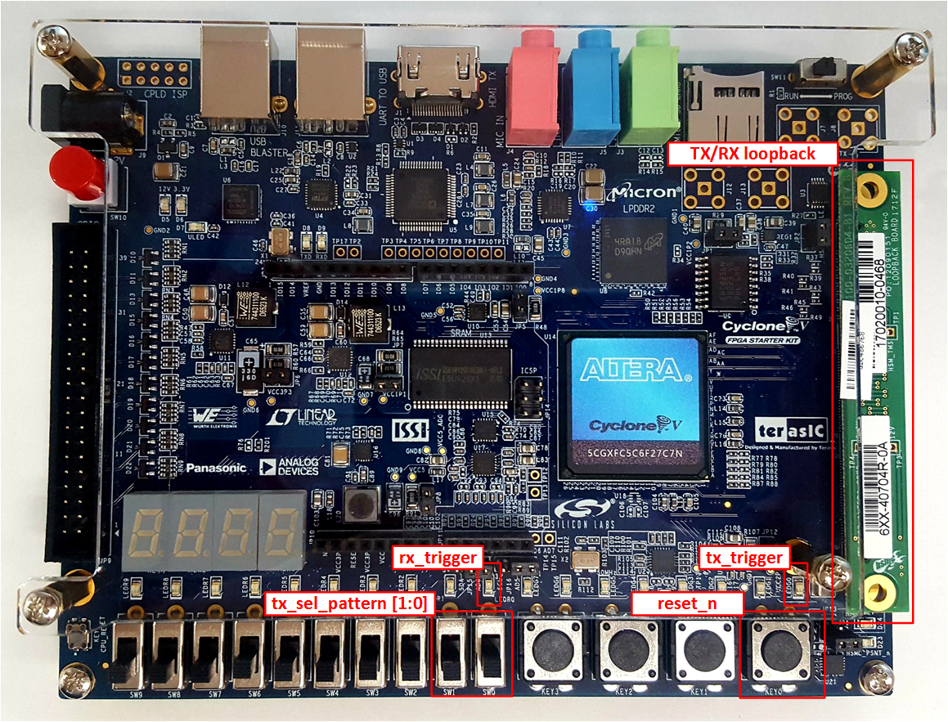

Step 10: Perform System Test
Before running the system test, set the ‘tx_sel_pattern’ switches to low position. This will make the TX channel to send the alignment pattern to the RX channel. Any other ‘tx_sel_pattern’ configuration will prevent the channels to align.
We will be using ‘Signal Tap’ as a medium to confirm the correct operation of our design. ‘Signal Tap’ allow us to capture and display the behavior of signals inside our design, it is like a logic analyzer build in the FPGA.
‘tx_parallel_data’ and ‘tx_trigger’ will be used to monitor the behavior of the TX channel. ‘tx_parallel_data’ will show the data that is being injected to the TX channel and ‘tx_trigger’ will be set to one each time that the data generator module had finished a calibrate – transmit cycle.
‘rx_parallel_data’ and ‘rx_trigger’ will let us monitor the data that is being received through the RX channel. ‘rx_trigger’ will be set to one each time that a complete cycle of calibrate – receive cycle has been completed.
The behavior displayed on Signal Tap will match the behavior seen in simulation.
First let’s open the Signal Tap used in this design. Go to ‘Project Navigator’ pane and in the drop-menu select ‘Files’. ‘parallel_data_snoop.stp’ should be visible. Double click on the file to open it.
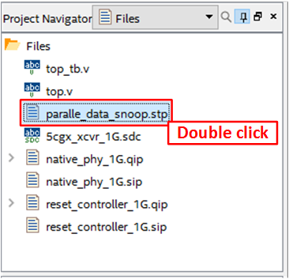
Signal Tap will open in its ‘setup’ view. Here all parameters for the capture are specified. In first place, the list of signals to be tracked are defined. In this case, both parallel interfaces for the TX/RX channels are included as shown under ‘1 Signals to be capture’ on the figure below. Also, ‘tx_trigger’ and ‘rx_trigger’ are added as markers for the transmit/receive cycles executed on the native PHY. ‘2 Trigger’ show the condition that Signal Tap will wait to start a data capture, for this exercise Signal Tap will wait for a rising edge of ‘tx_trigger’. ‘tx_std_clkout’, the clock source generated by the transceiver TX PCS, will be used as sampling clock as shown on ‘3 Sampling clock’. Each rising edge from the latter clock will capture the current value of each signal to be sampled. The number of samples to be captured per event is defined to ‘512’ on ‘4 number of captures’.
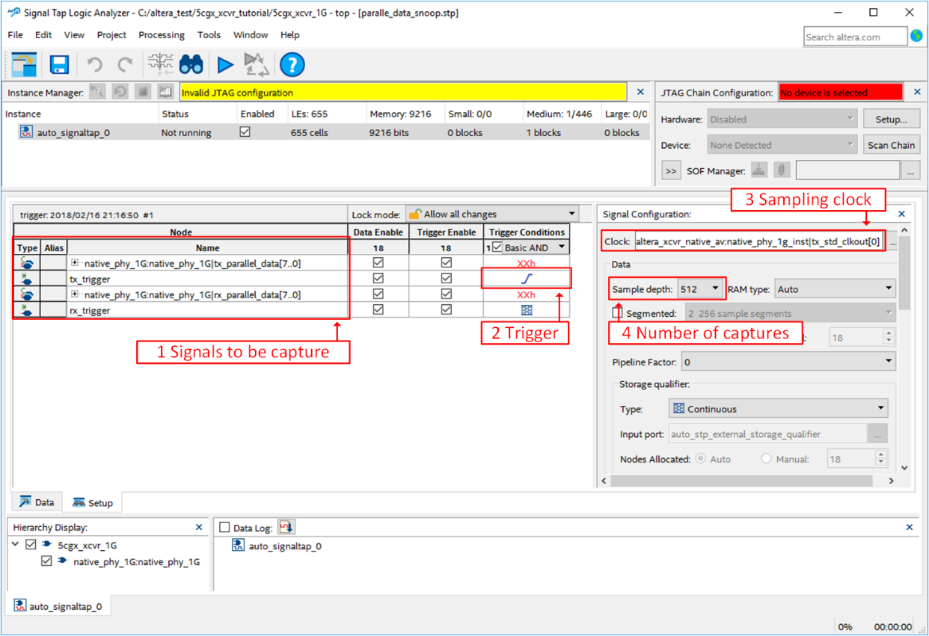
To include Signal Tap into the design, go back to Quartus, click on ‘Assignments’ menu and then click ‘Settings’.
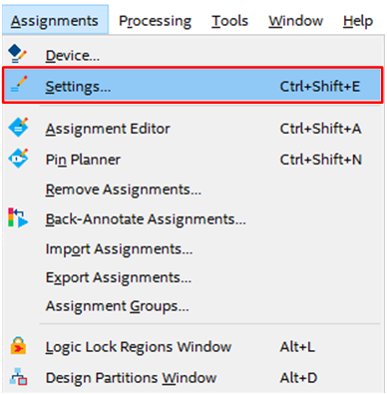
In ‘Settings’ window, click on ‘Signal Tap Logic Analyzer’ category and make sure that ‘Enable Signal Tap Logic Analyzer’ is checked. Also, ‘Signal Tap File name’ should be pointing to ‘parallel_data_snoop.stp’. Click ‘OK’ to apply any changes.
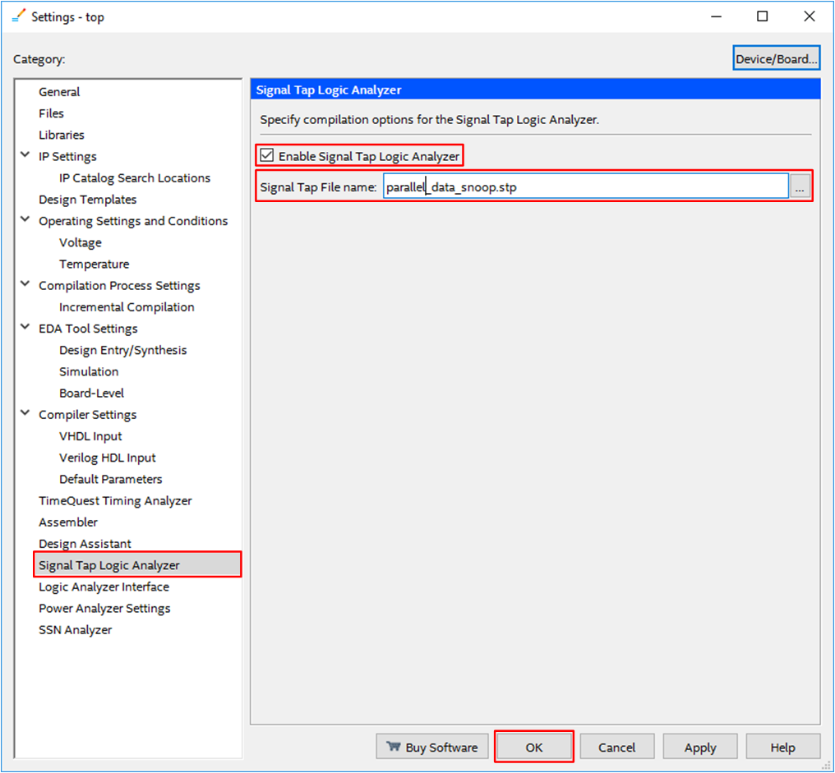
Once the changes have been made it is necessary to recompile the design to include Signal Tap in it. Click the ‘compile’ button on Quartus Tool Bar.
Make sure that you have check all points from STEP 9: BRINGUP DEVELOPMENT BOARD before proceeding with this guide. Also, the development board should be turned on.
With a successful compile, we can proceed to load the design. Click the ‘programmer’ button on Quartus Tool Bar.

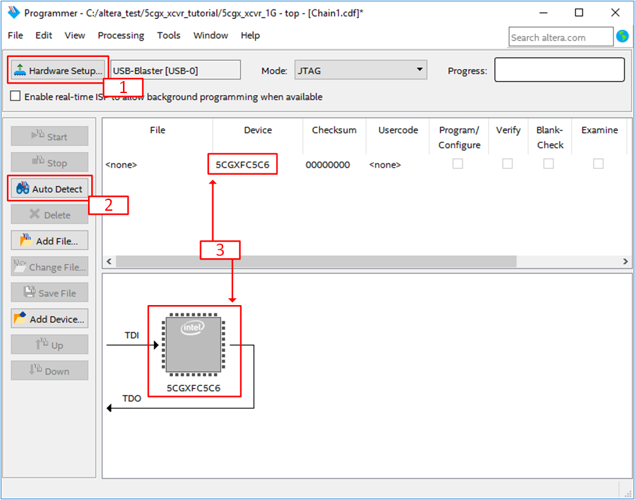
On the programmer window click on ‘Hardware Setup’ A new window will appear, double-click on ‘USB-Blaster’ on the ‘Available hardware items’ list. Once ‘USB-Blaster’ is selected on ‘Currently selected hardware’ click ‘Close’.
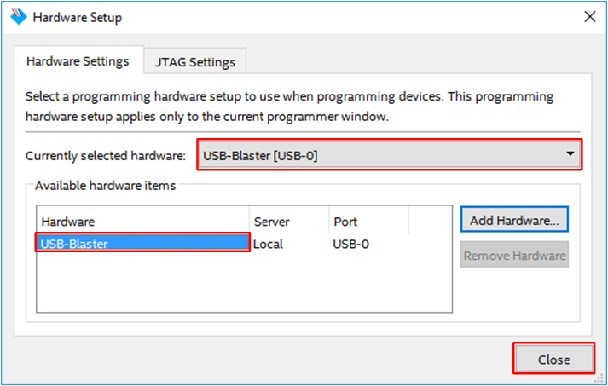
Click on ‘Auto Detect’ Button to discover all devices connected to the JTAG chain. ‘Select Device’ window will open, select ‘5CGXFC5C6’ as target device.
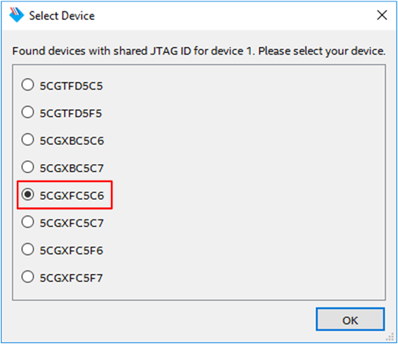

Now, let’s select the bitstream file generated after our design compilation. Double click on ‘<none>’ under ‘File’, a File browser window will appear. Select ‘top.sof’ under ‘output_files’ folder.
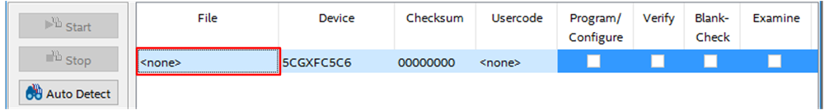
Once ‘top.pof’ is selected, click on ‘Program/Configure‘ checkbox. After that click the ‘Start’ Button.
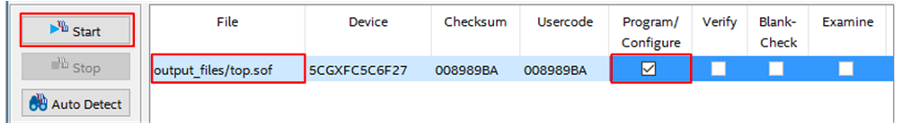
The FPGA is now configured with the transceiver design. Return to Signal Tap window to start a capture.
You can also open Signal Tap selecting ‘Signal Tap Logic Analyzer’ from Quartus ‘Tools’ menu.
First, configure the JTAG chain for Signal Tap. Click on ‘Hardware’ drop menu and select ‘USB-Blaster’, a boundary scan will start automatically. If everything is ok the Cyclone V ion the development kit will be found.
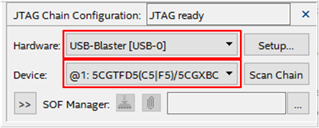
The postfix after USB-Blaster ([USB-0] in the figure) can vary between computer or user sessions. In case that the Boundary scan didn’t start automatically press ‘Scan Chain’ button.
Click on ‘Processing’ menu and select ‘Run Analysis’ to start Signal Tap on hardware. The Capture will happen after the next occurrence of the defined trigger (rising edge of ‘tx_trigger’). Signal Tap will automatically switch to its ‘Data’ tap and show the captured data.
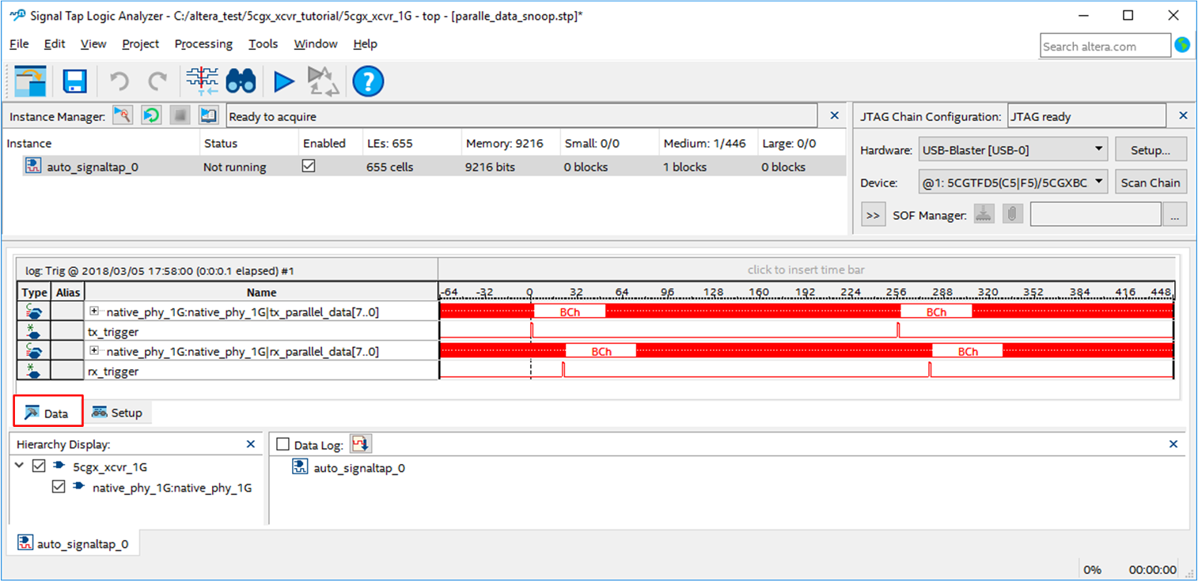
The capture follows the expected behavior, with alignment cycles followed by transmission cycles. Left click on the waveform to Zoom in and Right click to Zoom out.
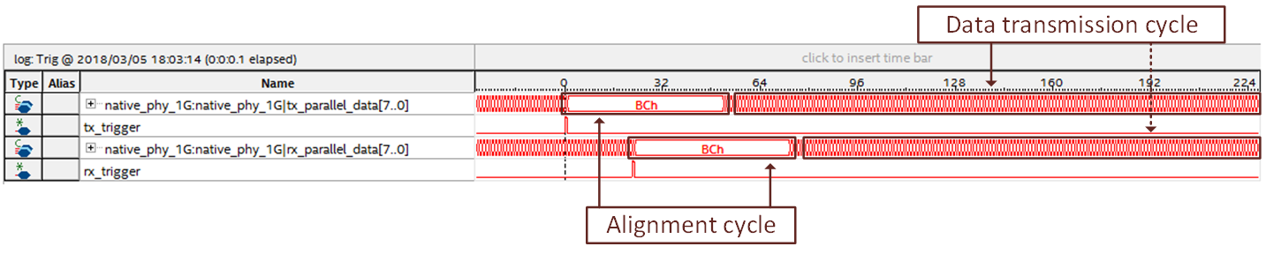
As expected, the simulation and the hardware run have the same behavior.
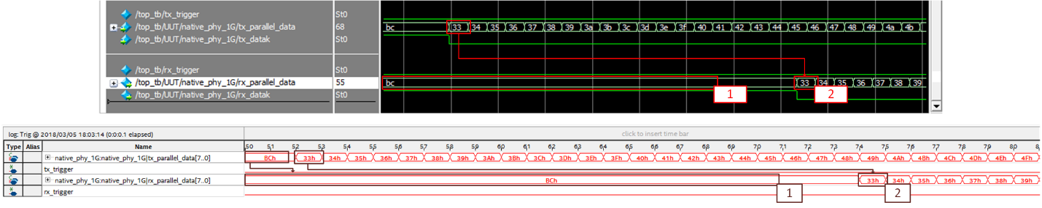
Congratulations! The transceiver is working properly in hardware.

Summary
Congratulations, you just created a functional communication lane running at 1250 Mbps. You started by creating and configuring a Cyclone V native PHY and its respective reset controller, taking care of adjusting the reference clock for the native PHY to support the desired bandwidth. Next, you made sure that the native PHY, the reset controller and the provided traffic generator were connected together, assembling all the required hardware to create the communication link.
Running a functional simulation, you have confirmed that all the components from the design will behave as expected, that all of them are configured properly to work together. Performing this step, you have ease the physical bring up of the transceiver channel, as you are sure that there is nothing wrong with the configuration of the IP blocks. You finished the preparations for the physical bring up of the board launching the compilation of the design, creating the configuration bitstream for the FPGA in the development board.
For the physical channel bring up, you made the connections between design ports and physical pins of the FPGA, also, you created the physical link between TX and RX y connecting the HSCM daughter card. After providing power to the board and connecting it to your PC, you proceeded to configure the FPGA and make a capture of the most relevant signals of the design with Signal Tap.
Finally, you proceeded to analyze the Signal Tap capture to make sure the proper behavior of the design in hardware.

